Purpose
The Digital Change Management Process is the practices and processes used to maximise the number of successful changes to Digital services and products, through ensuring that risks have been properly assessed, authorising changes to proceed and managing the change schedule.
It is defined through the following ecosystem of documents:

This document, the Digital Change Procedure, provides day to day guidance on completing the activities required to plan, approve and implement changes.
This procedure is system agnostic. The associated document “Digital Change Guideline - SDP Guide” provides detail on how these activities translate into the Wannon Water’s IT Service Management tool - ServiceDesk Plus.

Scope
This procedure applies to any employee or contractor in Wannon Water who is involved in the change process (including change requests) where the change will be made to a Digital Platform overseen by a Change Authority.

Procedure Overview

Change Category
The Digital Change Procedures varies according to the Change Category.

Note that Business as Usual changes are out of scope for the Digital Change Management Procedure.

Change Workflow
Broadly, changes progress through the following stages:

Submit | Register the change, including capturing key details such as the change category and risk, the implementation window, the services which will be impacted and the key roles.
Plan | Capture key information about the implementation plan, including:  - Implementation steps  - Verification approach  - Stakeholder communication  - Backout or contingency plans  - Outages impacting users or services
Approve | Depending on change category and change risk, recommendation and/or approval by:  - Change Authority  - Change Manager  - Change Advisory Board
Implement | Execute implementation plan.
Review | Identify and capture learnings to improve the change process/reduce change risk in the future. This procedure mandates review in certain circumstances.
Close | Record change outcome and close change.

Procedure – Overview
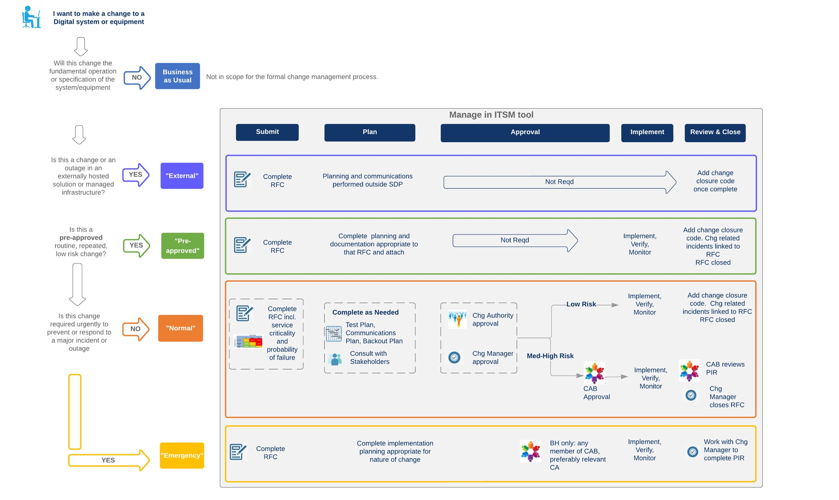

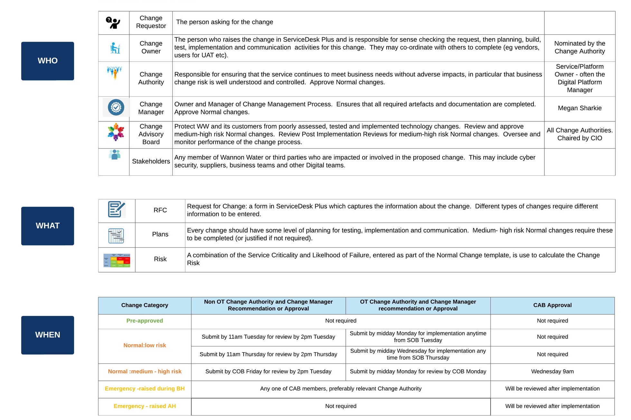

Change Design
This step takes place before the change record is entered into the ITSM tool. The objective of this step is to translate the need for a change into well designed change records. Well considered design avoids rework and sets the change(s) up for a smooth approval process, as well as making it more likely that they will be successful.
The key aspects of change design are:
- Change category.
- Related changes.
- Change risk.
These are described in more detail in the following sections.

Change Categorisation
When the need for a change is confirmed, one of the first steps should be to confirm the Change Category, using the definitions described in Section 3.1 Change Category.
It is expected that the Change Owner and Change Authority consider the risk and complexity of the individual change to inform the categorisation.
The category, combined with change risk, will determine the lead time required for approval of the change, and should be considered when scheduling the change implementation window.
In determining the category, the Change Owner and Change Authority should consider the guidance below:

If a Change Owner identifies a change which appears to be consistent with one of the pre-approved changes on the agreed list, they should ensure that the change is:
- Consistent with the definition of the pre-approved change category (routine, repeated and low risk).
- Consistent with the definition and intent of the specific pre-approved change.
If there is any doubt that it meets these criteria, it should be raised as a normal change.

An emergency change is a change which is required to prevent or respond to a major incident. Normal changes where an urgent implementation is desired due to considerations outside this such as staff availability do not meet this definition. In these cases, the Change Authority and Change Owner should work with the Change Manager to see if the approval process can be expedited.

Related Changes
Related changes occur when:
- There is a single change which needs to be applied multiple times across multiple instances. For example, applying a certificate to multiple apps/servers; migrating sites over to a new telecommunications protocol.
- Staggered rollouts. For example, rollout of an application update to laptops and desktops.

When planning these changes, the Change Owner and the Change Authority should work with the Change Manager to determine whether one or multiple changes should be raised.

When determining this, the following should be considered:
- Whether the change risk varies across the different change components.
- Whether the planning varies across the different change components.
- The requirement for a meaningful audit trail for anyone who might be scheduling a change or investigating an incident on the same service/infrastructure.

In making this decision, the Change Owner and Change Manager should consider the guidance below:
If the change rollout is staggered as part of good practice to minimise the impact in the very unlikely situation that something goes wrong, it is reasonable to include all the stages in one change record.
If the first stage is a pilot, and the learnings will be used to inform future state, then multiple changes are more appropriate to allow for easier changes to schedules or implementation plans.
A change record which runs over an extended period does not support easy identification of what has changed when. Unless otherwise agreed with the Change Authority and Change Manager, a change record should not cover a period of more than 5 days.
If in doubt, default to more change records rather than less. This avoids situations where a failure, alteration or rescheduling of just one part of the change requires the whole change to have to be resubmitted and reapproved.

Change Risk
The change risk is determined using Service Criticality and Probability of Failure. These are applied to determine a risk level according to the risk matrix below.

Note that the approval requirement for a normal change varies depending on the risk of the change.

Service Criticality
Services are defined to support the change process, and each has been assigned a criticality which reflects its importance to Wannon Water. The Change Manager will keep a record of the services and associated criticality, as well as the ITSM service definition including criticality.

Criticality is assessed according to the following definitions:
High – failure of this service would result in immediate/direct risk to public or employee health or safety or pose a significant environmental impact.
Medium – this service is used daily by many employees or is used by a department to deliver a time critical core process or service to stakeholders or customers.
Low – not core to day-to-day service delivery and would usually support processes which can be deferred until the system is available or there is a straightforward workaround or manual fallback.

Probability of Failure
“Probability of Failure” includes a broad range of scenarios, including the change being unable to be implemented, the implementation not going to plan or the change causing incidents or issues after implementation.
This is assessed considering factors such as the number of systems or assets being impacted by the change, the amount of effort to design, build and plan the change, the inherent stability and complexity of the service, the complexity of the implementation, confidence in the rollback procedure and whether a similar change has been successfully completed previously.

Procedure – External Change
An external change is a change being made to Software as a Service or externally managed infrastructure, where the change is not initiated by Wannon Water, and Wannon Water has no control over the timing or content of the change.

These changes are recorded centrally for visibility i.e., for consideration in scheduling other changes, incident investigations or responding to queries from end users.

Submit | Change Owner completes the Request for Change template for external changes
 | On completion of submission, the ITSM tool will automatically notify IT Operations, the Change Authority, and the Change Manager.
Plan | The ITSM tool does not require any information to be captured, however the Change Owner should:  - Action or schedule any stakeholder communications required.  - Plan and schedule any co-requisite changes.
Approve | Not applicable for external changes.
Implement | Not applicable for external changes.
Review | Not applicable for external changes.
Close | Change Owner to record change outcome and close change.  If the change outcome was not successful it should be reported to the Change Manager for review in the Change Advisory Board

Procedure – Pre-approved Change
Pre-approved changes are routine, repeated, low-risk changes.

Pre-approved Change List
Each portfolio has an agreed list of pre-approved changes. This is stored in the ITSM tool; however, the Change Manager will also maintain a separate list to ensure that there is an audit trail of changes to this list.

Additions and Changes
The list of pre-approved changes can be refined or added to as follows:
- Digital Team member identifies a candidate change or a change to an existing pre-approved change.
- Change Owner works with Change Authority to agree or refine a definition which ensures that the scope of the pre-approved change is clear and that higher risk changes cannot be included in error.
- Once a clear definition is agreed, the Change Authority should provide the details to the Change Manager.
- The Change Manager should update the ITSM tool, update the pre-approved change audit log and update all impacted change process participants.

Deletions
A pre-approved change can be deleted from the list as follows:
- Change Authority provides the details to the Change Manager.
- The Change Manager should update the ITSM tool, update the pre-approved change audit log and update all impacted change process participants.

Pre-approved Change Process
Submit | Change Owner completes the Request for Change template for pre-approved changes for the affected Digital Platform.
 | On completion of submission, the ITSM tool will automatically notify IT Operations, the team associated with the affected Digital Platform, the Change Authority, and the Change Manager.
Plan | The ITSM tool does not require any information to be captured, however the Change Owner should:  - Action or schedule any stakeholder communications required.  - Ensure that the plan is consistent with any related standards procedures or guidelines.
Approve | Not applicable for pre-approved changes.
Implement | Change Owner captures any notes from the implementation.
Review | If there were any issues with the change implementation, Change Owner consults with Change Manager to complete PIR.
Close | Change Owner to record change outcome and close change.

Procedure – Normal Change
Submit | Change Owner completes the Request for Change template for normal changes for the affected Digital Platform.  When submitting normal changes, consider that the risk of a normal change will impact the approvals required and the lead time to obtain these.  There will be an advertised schedule for review and approval of normal changes.  Where approval for a normal change is required outside this schedule, the Change Owner should work with the Change Manager and Change Authority to agree an approach.
Plan | Where relevant, the following information should be captured in the ITSM tool:  - Implementation steps.  - Verification approach.  - Stakeholder communication.  - Backout or contingency plans.  - Outages impacting users or services.  - Any other useful information which mitigates or increases the risk of the change.
The information should be consistent with any relevant standards, procedures, or guidelines.
On completion of planning, the ITSM tool will automatically notify IT Operations, the Change Authority, and the Change Manager.
Approve | In the case of a low-risk normal change, the change will be submitted for approval to the Change Authority and Change Manager.  In the case of a medium-risk or high-risk normal change, the Change Authority and Change Manager will review and recommend to the Change Advisory Board, who will then approve.  If there are concerns with the change, in the first instance the reviewers and approvers will work with the Change Owner to refine the change to resolve the issues. Outright rejection of a change should only happen if this avenue has been exhausted.  It is the responsibility of the Change Owner to ensure that the change is approved before implementation commences.
Implement | Change Owner captures any notes from the implementation.
Review | Low-risk changes: if there were any issues with the change implementation, Change Owner consults with Change Manager to complete a post implementation review.  Medium-risk and high-risk changes: all these changes require a post implementation review.
Close | Low-risk changes: Change Owner to record change outcome and close change.  Medium-risk and high-risk changes: Change Manager to record change outcome and close change.

Procedure – Emergency Change
Submit | Change Owner completes the Request for Change template for emergency changes.  If the emergency change emerges outside business hours, it is not necessary to have recorded the change before implementation, however the Change Owner should aim to complete the Request for Change as soon as practicable.
Approve | If the change emerges during business hours, the change will require approval of EITHER the Change Authority or the Change Manager, preferably the Change Authority.  If neither is available within a reasonable timeframe, approval can be sought from any member of the Change Advisory Board. Approval may be verbal or email and should be noted in the change.
On completion of approval, the ITSM tool will automatically notify IT Operations, and the Change Advisory Board.
It is the responsibility of the Change Owner to ensure that the change is approved before implementation commences.
Implement | Change Owner captures any notes from the implementation.
Review | Change Owner to work with Change Manager and Change Authority to complete post implementation review (required for all emergency changes).
Close | Change Manager to record change outcome and close change.

Procedure – Rescheduling Changes
Scenario 1: Change is in Planning Stage.
Change Owner returns the change to submission to update the implementation date.

Scenario 2: Change is in Approval or Implementation Stage but has yet reached implementation date.
Change Owner advises the Change Manager to update and, if necessary, arrange for the change to be re-approved.

Scenario 3: Change implementation date is past.
Change Owner closes change and records that the change has been cancelled and the reason why. The procedure to close the change should be consistent with the procedure for the applicable change category.

Procedure - Post Implementation Review
The following changes are in scope for Post Implementation Review (PIR):
- Any change which does not go to plan.
- Any unauthorised change.
- Any medium-risk or high-risk normal change.
- Any emergency change.

The Change Manager will co-ordinate the completion of the PIR with the Change Owner and Change Authority and any other stakeholders.

The PIR focusses on learnings to improve change outcomes going forward. The exact approach and scope of this may vary, but at a minimum will cover:
- Learnings which could help avoid recurrence of the issue.
- Learnings which could help reduce any adverse impacts if the issue recurs.
- Identification of actions which were completed which positively impacted the change outcome and should be adopted as common practices or incorporated into procedures.

If the change went smoothly or if there are clearly no learnings, the Change Authority can waive the requirement for a PIR.

Related Processes

In the case where the PIR process identifies a reportable event, a recommendation will be included in the PIR for the Change Authority to raise a risk incident. For definitions of reportable events refer to Incident Reporting and Response Procedure.

Individual feedback relating to performance of change related activities is out of scope for the PIR process.

Unauthorised changes will be reported to the Information Security Manager for evaluation and possible further action under the Cyber Risk and Access Management Frameworks.

Reporting

The Change Manager will report all findings from Post Implementation Reviews to the Change Advisory Board, including where either it has been waived or where recommendations include raising of a risk or cyber incident.

Procedure: Unauthorised Changes
An unauthorised change includes
- Changes made to the production environment where no change record was raised.
- Changes made to the production environment where the change did not have the necessary approvals completed before implementation started.

Anyone who identifies an unauthorised change should report it as soon as possible to the relevant Change Authority.

In the case where a change is completed with no change record being raised, the Change Owner or Change Authority works with the Change Manager to raise a retrospective change to record the details of the change.

The Change Manager will ensure that unauthorised changes:
- Are reported to the Change Advisory Board.
- Have a Post Implementation Review completed in line with the procedure documented in Section 3.10.

Roles and responsibilities
Position | Roles and responsibilities
Change Manager | Manager of Change Management Procedure.  Ensure that all required artefacts and documents are completed to required levels.  Co-ordinate Change Advisory Board.  Complete approvals, reporting and other analysis as required.
Change Requestor | The person asking for a change to be made
Change Owner | The person who raises the change in ServiceDesk Plus and is responsible for sense checking the request, change design and overseeing or completing Submission, Planning and Implementation.
Change Authority | The person responsible for ensuring that a service or set of services continue to meet business needs without adverse impacts, in particular that business change risk is well understood and controlled.  This is not a standalone role: rather it is an accountability performed as part of another role, often a Digital Platform Manager.

Definitions
Term | Means
Change Category | A category determined by complexity and risk of the change. It is used to determine the level of planning and what approvals are required.
Change Advisory Board (CAB) | A board responsible for protecting Wannon Water and its customers from poorly assessed, tested and implemented technology changes. This is further detailed in the Change Advisory Board Charter
ITSM | IT Service Management – a set of processes used by IT to manage the delivery of services
ITSM Tool | The tool used to support ITSM processes. Currently ServiceDesk Plus supplied by ManageEngine
PIR | Post Implementation Review – completed after a change to identify learnings to reduce risk and improve change outcomes for future changes

Governance
Parent policy/standard | Digital Change Policy
Associated procedures/standards | Digital Change Advisory Board Charter  Digital Change Guideline – Change Authority Responsibilities  Digital Change Guideline - SDP Guide
Relevant legislation | -
Approval | Chief Information Officer
Procedure owner | Change Manager
Content enquiries | Change Manager

Document version history
Version | Changes made to document
1 | New document
2 | Expanded Post Implementation Review procedure to link to related processes (section 3.10 and 3.11).  Clarified role of Change Owner in ensuring changes are approved before implementation.  Added OT Change Approval Schedule to Section 3.3.

